NCAA BOYS’ FOOTBALL 2017-2018

1. Please refer to the entire NCAA constitution found online at www.ncaa.ca for all playing regulations

2. Junior | Level | Boys NCAA,ZONE; SOSSA
Senior | Level | Boys NCAA,ZONE; SOSSA; OFSAA
3. Memb | ers: 8 NCDSB | High Schools

- Executive:
EXECUTIVE COMMITTEE ROLES OF THE EXECUTIVE STANDING COMMITTEES
Section 1 - Board of Reference - GENERAL

- CONVENERSHIPS
Section 1 - Athletic Conveners
Section 2 - Athletic Convener Packages

- SOLICITING STUDENTS Will not be tolerated

- INSURANCE As per NCDSB/NCAA regs

- PERSONAL PROPERTY Not responsible for

- TEAM SELECTION As per school and regs

- SAFETY See OPHEA guidelines
As of November 2010, all protective equipment must be covered by the pants or jersey. All eye shields (visors) must be clear .
colored or tinted eye shields (visors) are illegal.

- SUPERVISION OF INTERSCHOOL TEAMS

- ELIGIBILITY Section 1 - School

As of the 2014-2015 school year, there will be three separate divisions of football. The Golden Horseshoe Bowl rep will come from the AAA division. Any school wishing to compete for the right to play in the Golden Horseshoe Bowl game must declare up to play in the AAA division. This is a temporary motion and may be put forward again.

Senior Level - The following classifications shall apply for SENIOR BOYS’ FOOTBALL:
“A” under - 500 students “AA” 501-950 students “AAA” 951and over

Junior Level - The following classifications shall apply for JUNIOR BOYS’ FOOTBALL:
“A” – developmental division with open membership. This division allows any weak, developing or new junior programs a competitive opportunity regardless of school size. This developmental division would have no involvement at, and willingly forfeit any privilege to compete at SOSSA or OFSAA levels.

“AA” over 800 students

Note: School SENIOR classification “A,AA,AAA) is based on enrolment on October 31 of the previous school year. Section 2 - Individual
Junior: not reached his/her 16th birthday by Aug. 31st of the current school year.
Only students in their first two years of high school, based on the date they entered grade nine, will be eligible for junior team competition.
For further clarification of junior eligibility, please refer to the NCAA Constitution

EXCEPTION: a student who has been accelerated one year in elementary school shall be allowed to play at the junior level for a maximum of two (2) consecutive years in the first three (3) years of his/her high school career. The student shall meet the above age requirement and documentation of the acceleration shall be provided with the eligibility sheet. (As of September 2009)

Senior: not reached his/her 19th birthday by Jan. 1 prior to the start of the current school year.
FOR THE 2016/17 SCHOOL YEAR, A SENIOR WILL BE BORN IN 1997 or LATER.

Section 3 - Special Consideration
13. | TRANSFERS
STANDING COMMITTEE(S)
Section 2 - Board of Reference - TRANSFER
Transfer meeting dates will be published the first week in Sept. of the current school year.
Section 1 - Transfer Policy
Section 2 - Ineligible Ruling
Section 3 - SOSSA Appeal Process
14. | SCHEDULING
 | Section 1 | - Declaration of Play
 | Section 2 | - School Classification
 | Section 3 | - League and Play-off Format
 | Section 4 | - Stages of Scheduling
SPORT SPECIFIC POLICIES:
15. | ELIGIBILITY SHEETS
16. | GAME TIME:

Up to the end of October, a game will start at 1:00 (no earlier without Convener’s knowledge and both Principals’ permission). After the end of October (Time Change), start times for games will be determined by both schools playing and the Convener.
Home games may be played on a turf field without the consent of the visiting team. If game time is other than 3:00pm, the home team must have the consent of the visiting team’s coach and principal.

ALL SENIOR OR OTHER APPROVED GAMES HOME GAMES START AT 7 PM. This start time must be approved by the visiting team. Junior starts times may vary before Senior.

  - GAME DAY AND SCHOOL RESPONSIBILITIES: Home Schools:
    - prepare the field, which includes lining the field
    - provide and prepare minor officials (chain gang, scorekeeper and timer)

use NCAA score sheets
    - provide a suitable leather game ball - game ball must be CFL or CIS approved.
    - as of April 2011,both sets of players’ benches must be on the same side of the playing field. Spectator areas will be on the opposite sideline of the players’ benches. Where this cannot physically be possible, the players’ bench areas must be clearly defined and spectator areas are not to be in those areas.

18. | OFFICIALS: | All officials must be accredited.
19. | OFFICIAL RULE BOOK: |  | Zone policies first, then the Canadian Amateur Rule Book for tackle Football.
 | All NRHSAA football leagues will be governed by the Canadian Amateur Rule Book for Tackle Football with the following
 | exception:
 | -field dimensions may vary from school to school;
 | For all NCAA junior and senior football leagues: |  |  | NO TIE GAMES: | FOLLOW CIS/CFL RULE:

START AT THE 35 YARD LINE WHERE EACH TEAM GETS A SERIES OF PLAYS UNTIL ONE TEAM
BREAKS THE TIE. (As of March 2014 this rule is in effect for ALL leagues, not just the Bowl Bound league)

2005 - Rule Clarification: re: BLOCKING BELOW THE WAIST: (addition to Rule 4: Section 5: Article 1)

ON ANY PLAY, BLOCKING BELOW THE WAIST IS ILLEGAL EXCEPT, IN THE CLOSE LINE PLAY AREA BY A PLAYER WHO IS OCCUPYING A POSITION IN THIS AREA AT THE SNAP OF THE BALL.

- TIMING OF GAMES:
1st and 3rd quarters are 12 minutes of straight time; unless there is a time out, injury time out, penalty on the play, long gain, incomplete pass (for 2014-2015 football season passed at October 28th, 2013 NRHSAA semi-annual meeting) and/or touchdown scored.

2nd and 4th quarters are 12 minutes with the last 3 minutes STOP TIME; ie time stops at the whistle that ends the play and starts when blown in by the referee signal.

The last minute of each quarter is indicated by a raised red flag.

In the 2nd and 4th quarters, the timer will, at the nine minute mark, make the head referee aware that there are three minutes left in said quarter.

- PAYMENT OF OFFICIALS

Each school participating in any level of Zone Football will be billed at the conclusion of the regular season and then playoff participants will be billed a second time after the championship games.

The designated amount will be a calculation determined by the convener and invoiced by the coordinator.

- REPORTING SCORES

For the 2016-2017 football season:

The home team will report the scores to the Athletic Convener in charge.
Both teams are responsible for writing up the game sheet and sending it in to the convener. Beginning the 2014-2015 football season: (as of October 28th 2013 )
The home team will report the scores to the Athletic Convener in charge.
Both teams are responsible for writing up the score sheet and sending it in to the convener. If only one score sheet is presented to the convener, it will be deemed to be the official score sheet, regardless of origin, ie home or visiting team’s score sheet. Score sheet should be signed by either the official or the opposing team’s coach. If no score sheet is presented to the convener, the official score will be deemed to be the one sent to the convener’s office. In this scenario, there will be no “official” half-time score for Tie Breaking Procedures.

- SUSPENSIONS ARTICLE XXV Section 1 - Ejection from competition

Section 2 - Physical or Verbal Altercation

24. | STANDING COMMITTEE(S)
 | Section 3 - Board of Reference - | SANCTIONS AND PROTESTS
 |  | Procedures
 |  | Penalties
 |  | Protests
 |  | Procedures

- LEAGUE AND PLAY-OFF FORMAT:

The format for league competition and play-offs will be determined at the Atheltic Designates and Conveners Individual Sport Body Meeting. All schools participating are to send a representative to the Conveners Individual Sport Body Meeting otherwise forfeit all rights for input in the league and play-off format.

Any game / match not played will be recorded by the convener as a win for the school who did not forfeit.
In team sports where standings are used to determine play-offs, the win/loss achieved against teams that drop out will be taken away (not added) to teams that are still yet to play them.

If a gate is charged at an NCAA/NRHSAA league or play-off game then all expenses will be paid from the gate (referees, minor officials, linesmen, security, score keepers, etc.) and the remainder of the gate will be divided equally between the home and visiting team.

- TIE BREAKING PROCEDURES when determining a play-off position when a league schedule leads to play offs:

  - Record between tied teams (HEAD to HEAD);
  - Record against teams higher in the standings (1 above, then 2 above, etc.);
  - Record against teams lower in the standings (1 below, then 2 below, etc.);
  - Points given up in the first half. If more than two teams are tied, then accumulative points given up in the first half among the tied teams. (head to head to head…);
  - Points given up in the first half against teams higher in the standings (1 above, 2 above, etc);
  - Points given up in the first half against teams lower in the standings (1 below, 2 below, etc);
  - (a) coin flip to determine play-off position only. No team can be eliminated from the playoffs by a coin flip. See NRHSAA Constitution, Article XVII, Section 26, Number 7b.
The conveners will determine a time and location for the coin flip. Schools involved may send the coach or a representative to verify the results. If a school is unable to send a representative the school that is present for the flip will choose “heads” or “tails”. If no school is present then the school that is alphabetically ranked highest will have “heads” in the coin flip (see appendix A1 and A2 for alphabetical listing for each zone). The convener will notify schools involved of the results.

    - In lieu of a coin flip eliminating a team from playoff participation, and, all other tie breaking procedures having been followed, a “playoff” on a neutral field will occur. Home field will be determined by a coin flip prior to the game. The “neutral field” can be eliminated if both coaches agree to play on a home field. Home team will still be determined by a coin flip.

    - In the event of a four way tie, the conveners in consultation with the NRHSAA Executive and the schools involved will determine a tie-breaking procedure.

- SOSSA INC.BOYS’ FOOTBALL:

Constitution and By-Laws: pages 1 to 25 of the SOSSA handbook; BOYS’ FOOTBALL: SOSSA Football Regs
1 champion from each Zone will go to SOSSA. The championship will held in the fall at least one week prior to OFSAA. Check ofsaa.on.ca for that date.

- CONVENING SOSSA CHAMPIONSHIPS ARTICLE XXIX

- An athletic therapist (first response) shall be present at each NCAA football game. The football convener will make arrangements for this service. Schools will be directly invoiced by the provider upon season completion. The home school shall cover the cost of this service.

30- Zone to provincials

Each sport must be considered separately for each Zone qualification to SOSSA and provincials as the number of teams per sport, division (junior and senior) and classification is not consistent from sport to sport. If more than one team exists within both NCAA and NRHSAA, a minimum of the top two teams (may be more depending on number of teams) in both NRHSAA and NCAA will compete in a cross-over to determine who will compete for the Zone entry into SOSSA. Example: Where the determination is the top two teams in both NCAA and NRHSAA, the NCAA champion will play the second place finisher in NRHSAA and the NRHSAA champion will play the second place finisher in NCAA. The champions within NCAA and NRHSAA will have home court/field advantage in the first round. The champion within NCAA or NRHSAA will retain home court/field advantage if a second place team defeats the champion in either NCAA or NRHSAA. Further discussion is needed regarding game location if the NCAA and NRHSAA champions are the two teams playing for entry to SOSSA. This example would be altered if it is more than the top two teams moving on for Zone qualification to SOSSA. Due to time constraints, there may be only one representative form NCAA and NRHSAA moving on to zone to complete the season. 2017 – Football hosts are NCAA
Reporting NCAA Football Scores 2017-2018

HOME TEAM MUST DO THE REPORTING

SCHOOL:

PERSON SUBMITTING THE SCORE:

You may PHONE in the results of a game to 905-735-0240 ex.117. When the home team phones in the scores, please provide the following information in your phone message: the sport/the day/teams that played/the winning school/and the final score of the game.

or, BETTER THAN PHONING, EMAIL ME the results AT: dino.germano@ncdsb.com

Convener within 24 hours of the game. You can enter scores online too.
An immediate paper trail is helpful. When you do FAX, USE THIS PAGE. (Also, IT IS SET UP FOR YOU to fax RESULTS TO THE LOCAL NEWSPAPERS as well).

FAX TO: | BERNIE PUCHALSKI |  | RECEIVING FAX#: | 905-684-6032 | (ST. CATH. STANDARD)
FAX TO: | Sports editor |  | RECEIVING FAX#: | 905-374-0461 | (NIAG. FALLS REVIEW)
FAX TO: | Sports editor |  | RECEIVING FAX#: | 905- 732-3660 (WELLAND TRIBUNE)
RE:REPORTING |  | NCAA High School Football |  | SCORES – 2016-2017

CHECK: SENIOR BOYS

JUNIOR BOYS’

DATE: # OF PAGES =

(Below) NAME THE: VISITING SCHOOL | (Below) NAME THE: HOME SCHOOL
FINAL SCORE: | FINAL SCORE:

****Make 10 copies of this page ****

NCAA — FOOTBALL SCORE SHEET

Date: | Time: | Division: | A | AA
 |  | AAA / AAAA
Home: | Visitor: | Category: | JR. | SR.

Scoring Totals by Quarter:
Quarter | 1 | 2 | 3 | 4 | Overtime | Final Score
Home
Visitor

Scoring Summary:
Type | Abbreviation |  | Point | Type | Abbreviation | Point
Touchdown | TD |  | 6 points | Convert | 1 pt. C / 2 pt. C | 1 point / 2 points
Single /Rouge | R |  | 1 point | Safety Touch | ST | 2 points
Field Goal | FG |  | 3 points
Team | Quarter # | Scoring Play — Player # |  |  |  | Total Score
H / V | Time |  |  |  |  | Home | Visitor

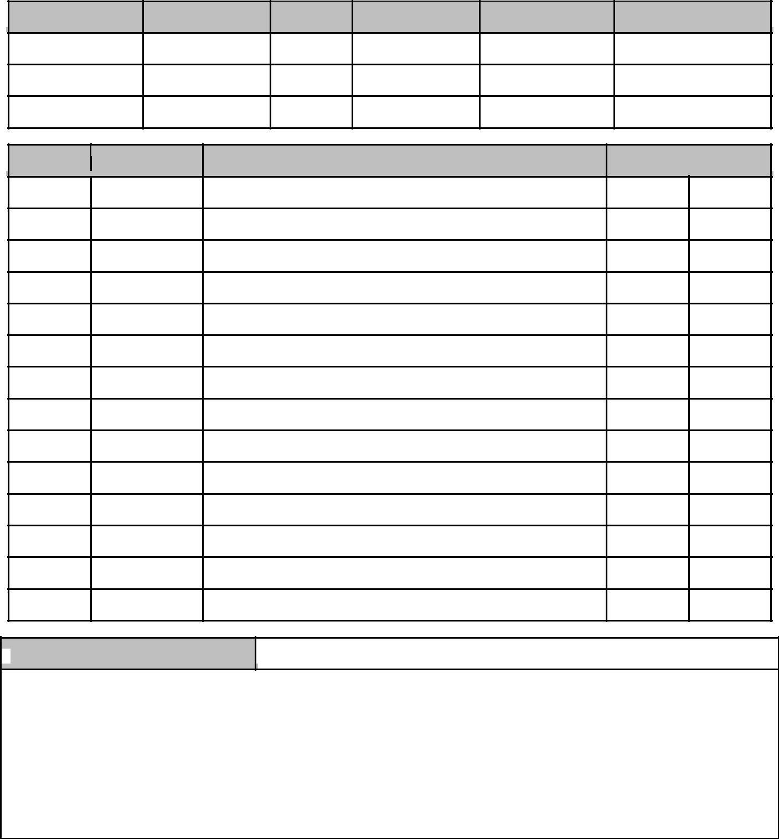white - athletic convenor pink - visitors yellow - home
Head Referee’s Signature:

Comments:

