2019 NCAA Wrestling Qualifiers
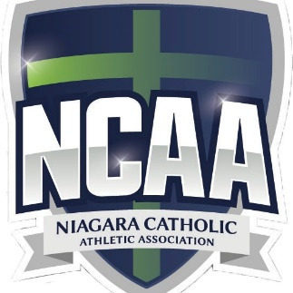

DATE: Friday February 8, 2019

VENUE: Blessed Trinity Catholic Secondary School
145 Livingston Avenue, Grimsby Ontario L3M 5J6

COST: $15/wrestler
Make cheque payable to: Blessed Trinity Catholic Secondary School -Wrestling Team

OFSAA WEIGHT CLASSES:
Men (kg): 38, 41, 44, 47.5, 51, 54, 57.5, 61,
64, 67.5, 72, 77, 83, 89, 95, UNL

Women (kg): 41 44 47.5 51 57.5 61 64 67.5 72 77 83 83+

Weigh-In Time: Please send in weights Tuesday February 5, 2019 by 3 pm to Megan.Schweitzer@ncdsb.com

NOTE:
- Eligibility sheets are due day of weigh ins. Please email a copy to Joseph.Pagnotta@ncdsb.com and Christopher.McLean@ncdsb.com
- All wrestlers who want to compete in ZONE MUST compete in the NCAA Qualifiers.
- A “Red Dot” system will be used with a 1kg allowance
- Team Points will be awarded for Team, Girls and Boys.

WRESTLING BEGINS: 10:00 am SHARP (please arrive by 9:15 am)
CONTACT PERSON: Megan Schweitzer Phone (905) 945-6706 (school) or (905) 541-4192 cell
E-mail megan.schweitzer@ncdsb.com

