Senior Girls Volleyball Tournament

Hosted by Niagara College Women’s Volleyball Team

10 Teams, 2 courts, 1 champion

Friday, December 6th, 2019

$200 Per team
4 games guaranteed

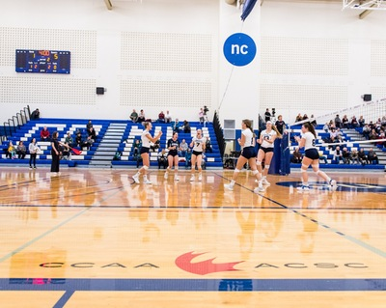

To register, Click & Complete

https://forms.gle/iqAqdcQHC3Xd7UzD9

For additional details Contact:
Steve Dow
sdow@Niagaracollege.ca

Tournament Info

Time | Court A |  |  |  | Court B
8:00 | A2 | Vs | A5 | B2 |  | Vs | B5
8:45 | A3 | Vs | A4 | B3 |  | Vs | B4
9:30 | A1 | Vs | A5 | B1 |  | Vs | B5
10:15 | A2 | Vs | A3 | B2 |  | Vs | B3
11:00 | A1 | Vs | A4 | B1 |  | Vs | B4
11:45 | A3 | Vs | A5 | B3 |  | Vs | B5
12:30 | A2 | Vs | A4 | B2 |  | Vs | B4
13:15 | A1 | Vs | A3 | B1 |  | Vs | B3
14:00 | A4 | Vs | A5 | B4 |  | Vs | B5
15:45 | A1 | Vs | A2 | B1 |  | Vs | B2
4:00 | 1ST A | Vs | 1ST B | 2ND A |  | vs | 2ND B

- Round Robin games are best of 2 with a cap at 27
- Playoff games will be best of 3 with no caps
- Ties will be broken with Volleyball Canada Tie Break Rules
- Games will run ahead of time up to 10 minutes if possible
- 1st Warm up will be a shared 3 min warm up then 4/4
- After 9:30 there will be 3 min to warm up then no hitting warm ups

