NIAGARA CATHOLIC ATHLETIC ASSOCIATION

NIAGARA CATHOLIC DISTRICT SCHOOL BOARD

CONSTITUTION

September 2021

Table of Contents

Mission Statement p.3
ARTICLE 1 NAME p.4
ARTICLE 2 PURPOSE p.4
ARTICLE 3 APPLICATION p.4
ARTICLE 4 MEMBERSHIP p.4
ARTICLE 5 FINANCES p.4
ARTICLE 6 NCAA OFSAA SANCTIONED SPORTS p.5
ARTICLE 7 TEAM SELECTION p.5
ARTICLE 9 STANDING COMMITTEES |  | p.7
ARTICLE 10 SUSPENSION |  | p.9
ARTICLE 11 ELIGIBILITY |  | p.10
ARTICLE 12 TRANSFERS |  | p.13
ARTICLE 13 SCHEDULING |  | p.14
ARTICLE 14 INSURANCE AND MEDICAL |  | p.15
ARTICLE 15 TRANSPORTATION |  | p.15
ARTICLE 16 SAFETY |  | p.15
ARTICLE 17 SUPERVISION OF SCHOOL TEAMS/INDIVIDUALS |  | p.16
ARTICLE 18 PAYMENT OF OFFICIALS |  | p.16
ARTICLE 19 REPORTING SCORES |  | p.16
ARTICLE 20 TIE BREAKING PROCEDURES |  | p.17
ARTICLE 21 HOSTING SOSSA AND OFSAA CHAMPIONSHIPS p.17
ARTICLE 22 GENDER EQUITY AND TRANSGENDER POLICY |  |  | p.17
ARTICLE 23 RECRUITMENT POLICY  Appendices: |  |  | p.17
Appendix A N.C.A.A. Notice of motion form |  |  | p.19
Appendix B NCAA co participation sport form |  |  | p.20
Appendix C NCAA Intention sheet |  |  | p.21
Appendix D NCAA School request for addition to league form |  |  | p.22
Appendix E Proposal for the addition of NCAA sport form |  |  | p.23
Appendix F NCAA-Transfers |  |  | p.24
Appendix G Fall sports intention |  |  | p.25
Appendix H Winter sports intention |  |  | p.26
Appendix I Spring sports intention |  |  | p.27
Appendix J Outside permission form for secondary coach |  |  | p.28
Appendix K Request to resume Athletics |  |  | p.29
Appendix L Request for exemption |  |  | p.30
ARTICLE 8 EXECUTIVE COMMITTEE AND MEETINGS p.5

NIAGARA CATHOLIC DISTRICT SCHOOL BOARD MISSION STATEMENT
The Niagara Catholic District School Board, through the charisms of faith, social justice, support and leadership, nurtures an enriching Catholic learning community for all to reach their full potential and become living witnesses of Christ.

Play Like A Champion TODAY!!!!!

Play Like A Champion today views sport as a ministry, and challenges coaches and the entire Catholic school community to develop the whole athlete: physically, mentally, and spiritually. The goal is to enhance our Catholic school athletic experience.

- Develop the skills and the morals of high school athletes.
- Maximize their athlete’s performance by setting targeted, appropriate goals.
- Understand the critical role that team community plays in sports.
- Instill a sense of accountability and ownership in their athletes.
- Recognize and address signs of abuse, including steroid use, bullying and sexual misconduct.
- Build strategic, beneficial partnerships with parents.

Play Like a Champion Today utilizes the GROW approach—a formula for success:

G

OALS +

R

ELATIONSHIPS +

O

WN

ERSHIP =

W

INNING

Utilizing the GROW approach, coaches lead with the pastoral training required to coach athletes that succeed on the field and that develop into virtuous adults. The Play Like a Champion Today approach to coaching leads to an improved sport experience for all involved in the game.

- Athletes experience less "burn out"; stay active for more years in sports.
- Coaches gain an increased sense of purpose and pride in contributing to their school's Catholic mission.
- Parents report greater satisfaction with their child's athletic experience.
- School administrators enjoy the benefits of professionally trained coaches committed to the Catholic identity of their school.

Extension of the Classroom

The Niagara Catholic District School Board through the Niagara Catholic Athletic Association (NCAA) supports a philosophy of athletic competition that is guided by the highest standards of good sportsmanship and fair play. The NCAA athletic program complements formal classroom learning and is an integral part of the total program of Catholic Education. Student athletes, parent(s)/guardian(s), administrators, staff coaches, volunteer coaches, support staff and spectators must recognize that participation in sports and co-curricular activities is an “extension of the classroom.” As such and where necessary, in compliance with current legislation and in keeping with the Board Mission, Vision and Values, the NCAA Constitution will be applied in conjunction with other Board Policies and Procedures.

Niagara Catholic Athletic Association Constitution

ARTICLE 1 - NAME

The Association shall be known as the Niagara Catholic Athletic Association (NCAA), a member of the Southern Ontario Secondary Schools Association (SOSSA) under the Ontario Federation of Schools Athletic Association (OFSAA). The NCAA consists of schools competing in SOSSA under the jurisdiction of OFSAA.

ARTICLE 2 – PURPOSE

The purpose of this Constitution is to assist in the promotion of the development of the whole person intellectually, physically, socially, and spiritually as referenced in the Play Like A Champion philosophy. Through its offerings, the NCAA plays an integral part in the personal formation and development of student athletes, preparing them for citizenship, service, and leadership.
The NCAA aims to facilitate student athletic development through inter-school athletic competition, conducted on a sound organizational and ethical basis built on a foundation of Faith and Learning.

ARTICLE 3 – APPLICATION

3.1 General
The NCAA Constitution governs the playing of member schools in the Niagara Catholic District School Board with links to the SOSSA and OFSAA Constitutions. Schools are expected to promote, supervise and conduct themselves within the athletic program of the member schools.
In all NCAA matters, the articles in the Constitution shall be applied first. Sport specific playing regulations will be referenced as required.
It is the responsibility of the school to review annually the NCAA Constitution and be aware of the articles within this document as they pertain, relate and differ from SOSSA and OFSAA Constitutions.

3.2 Governance
The NCAA Constitution governs NCAA league and playoff games.

ARTICLE 4 - MEMBERSHIP

The NCAA shall consist of all Catholic secondary schools within the Niagara Catholic District School Board. The member schools are listed below:

Zone II Saint Michael, Saint Paul, Notre Dame College, Lakeshore Catholic, Blessed Trinity, Saint Francis,
Holy Cross, Denis Morris

In order to be eligible for competition, member schools are required to remit NCAA and SOSSA fees.

ARTICLE 5 - FINANCES

NCAA Fees
The NCAA levy of $50 plus .50 cents per student must be paid annually by the member schools to the NCAA Convenor by November 15th. The NCAA levy and other monies received will support NCAA activities. Financial information will be shared at the AGM. The FTE numbers as of October 31st of the current school year are used for school population.

SOSSA Fees
Each member school must pay SOSSA fees to be eligible to participate in SOSSA and OFSAA Championships.
ARTICLE 6 - NCAA OFSAA SANCTIONED SPORTS

The following sports are governed by the NCAA. Please visit www.ncaa.ca sport pages for regulations.
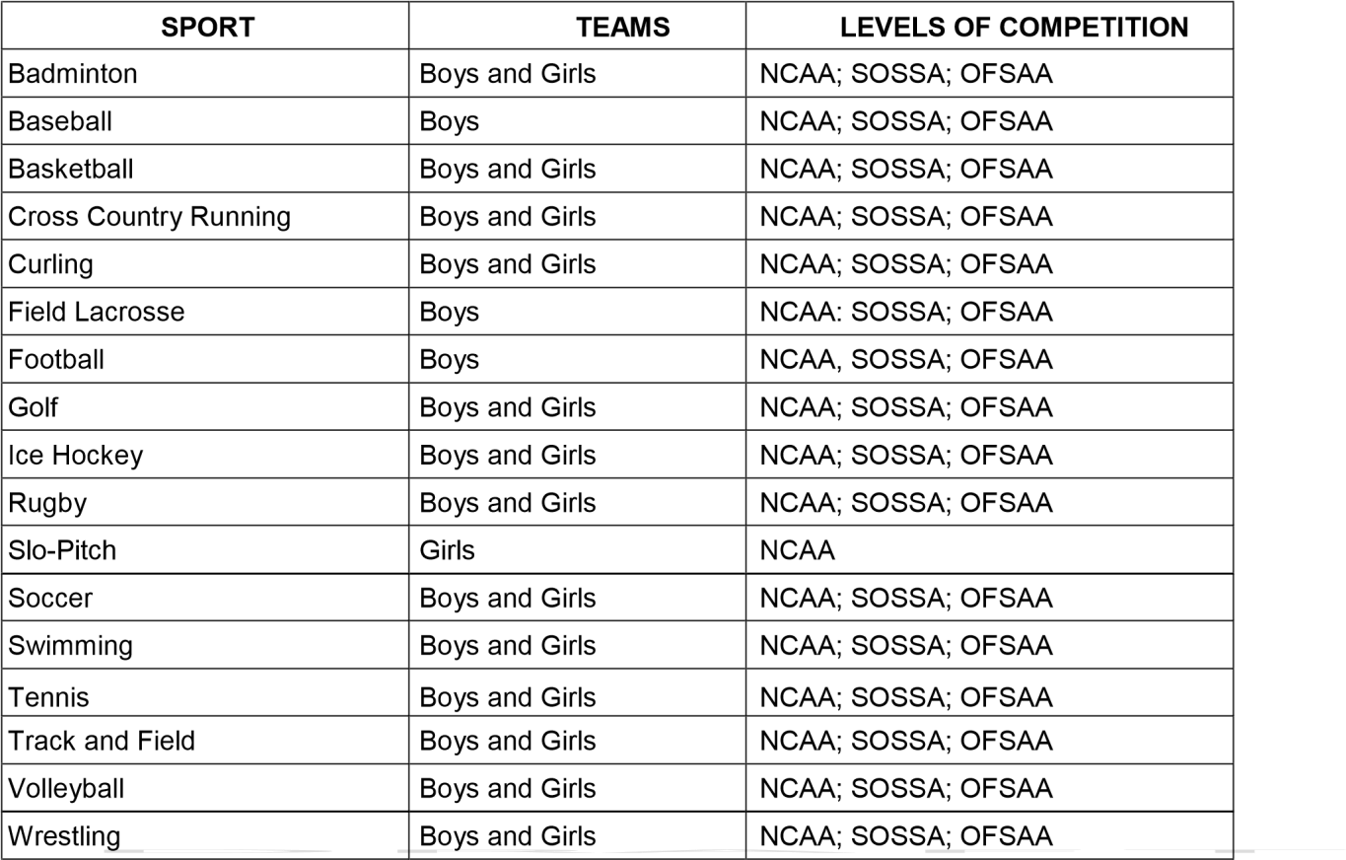
Ultimate Frisbee | Coed | NCAA; SOSSA; OFSAA

Additions to the list must come forward as a motion to a NCAA meeting. Each motion must be accompanied by a completed proposal for the addition of NCAA sport form (Appendix E).

ARTICLE 7 - TEAM SELECTION

Student-athletes are encouraged to experience a variety of sports. Sports that are “in-season” are to have priority over sports that are not. It is recommended that team selection occur after:
- The first day of school for fall sports;
- November 1st for winter sports;
- March 1st for spring sports.

ARTICLE 8 – EXECUTIVE COMMITTEE AND MEETINGS

8.1 Executive Committee
The Executive Committee consists of the Program Chairs of Health and Physical Education/Co-curriculars from each school, a Secondary Principals’ Representative and the NCAA Convenor. The Program Chair of Health and Physical Education/Co-curriculars (or principal's designate) from each school will be responsible for voting on all issues pertaining to matters within the NCAA. The Secondary Principals’ Representative and the NCAA Convenor are non-voting members. Each school has one vote.

Responsibilities
Secondary Principals’ Representative
- Non-voting member of the Executive Committee
- Selected by member school Principals at the first Secondary Schools Principals’ meeting of each school year
- Liaise to the NCAA on behalf of the Secondary Principals
- Liaise to the Secondary Principals on behalf of the NCAA
NCAA Convenor
- Non-voting member of the Executive Committee
- Oversees the day to day running of the NCAA
- Maintains and updates the Constitution
- Maintains and updates the sport specific policies
- Liaise with the Executive Committee, Coaches and Principals
- Submit motions at the NCAA meetings
- Collects the NCAA levy by November 15
- Provides a balance sheet at meetings
- Serves as a reference for all standing committees
- Serves as a reference and link to SOSSA and OFSAA

The members of the Executive Committee are responsible for sitting on a variety of standing committees when requested such as but not limited to those listed under Article 9.

The Executive Committee will nominate a designate to serve as a SOSSA representative every year.

8.2 Meetings
- Members of the Executive Committee will be expected to participate in scheduled meetings.
- Meetings may be conducted in a variety of formats (e.g. video conference, face to face, conference call, etc.) as deemed appropriate by the NCAA.
- Meetings are open to members only.
- A quorum of 50% plus one must be present for the meeting to occur.
- Motions will be carried with at least 60% support from present members at the meeting.
- Each school present has one vote for constitutional changes

8.3 Policy Making Procedures

a) Changes to the NCAA Constitution
The NCAA Constitution may be amended or changed at NCAA meetings.

b) SOSSA Policy that automatically become NCAA Policy
Any motion that is passed at OFSAA and/or SOSSA that affects the NCAA Constitution and/or NCAA sports will automatically become an NCAA policy.

c) Submitting a Motion (See Appendix A)
All proposed amendments and changes to the Niagara Catholic Athletic Association Constitution must be submitted on the Appendix A - NCAA Notice of Motion Form. All motions must be received by the NCAA Convenor two weeks prior to the NCAA Meetings.

The NCAA Convenor will circulate copies of all proposed amendments and changes to each Principal and Program Chair of Health and Physical Education/Co-curriculars one week prior to the NCAA Meetings. Principals and/or Program Chairs of Health and Physical Education/Co-curriculars are encouraged to discuss the proposed amendments and changes with those coaches within the school who have a stake in the outcome prior to the NCAA Meetings.

d) Voting on Motions
Mover and/or seconder will speak to the motion. If the mover and or seconder is not available to attend, the program chair of that school may speak to the motion. If there is no one available to speak to the motion, it will be tabled.

Members may speak for or against the motion one time only. NOTE: clarification of an issue is not considered a response.

After members have had an opportunity to respond, the mover and/or seconder may respond.

A quorum of 6 member NCAA schools must be present for constitutional changes. Each member school has one vote per motion. The Program Chair of Health and Physical Education/Co-curriculars (or Principal’s designate) will vote on each of the motions on behalf of their school. All notice of motion which affect the Constitution, in order to be carried, must have a 60 percent vote of those casting votes. Abstaining votes are not counted “for” or “against” a motion.

8.4 Minutes of Meetings

The NCAA Convenor will forward the minutes from each NCAA meeting and SOSSA meeting to the Principal and Program Chair of Health and Physical Education/Co-curriculars at each school.

ARTICLE 9 - STANDING COMMITTEES

In order to facilitate the operation of the NCAA, the following standing committees will be in place.

9.1 Transfer Committee (See Appendix F)

The Transfer Committee will consist of three members: Two (2) Program Chairs of Health and Physical Education/Cocurriculars and the NCAA Convenor. The NCAA Convenor will chair the committee.

In the case of unique and or sensitive transfer concerns, no Program Chair of Health and Physical Education/Cocurriculars can be involved in the decision of a transfer from their own school. An alternate Program Chair of Health and Physical Education/Co-curriculars from the member schools will be contacted by the NCAA convenor.

The Program Chair of Health and Physical Education/Co-curriculars shall be the only person in the school responsible for transfers in their school.

Procedures:

- The NCAA will abide by OFSAA’s Transfer Policy.

- All transfer students must complete the OFSAA Transfer Form from the www.ofsaa.on.ca website.

- Students must ensure that all pertinent documentation accompanies their form/application. Incomplete applications will not be accepted until all appropriate documentation has been received by the Transfer Committee chair. If a student does not submit all the necessary documentation needed, the student will not be reviewed until the next Transfer Committee meeting. Hence, the student is ineligible for competition until the case is reviewed and approved at the next Transfer Committee meeting.

- All transfer forms must be signed by the school Principal and/or the Program Chair of Health and Physical Education/Co-curriculars. All transfers for a given season must be received by the Transfer Committee chair no later than twenty-four (24) hours prior to the date of the Transfer Committee scheduled meeting.

- The dates of the Transfer Committee meetings for NCAA, SOSSA and OFSAA will be published by the end of June for the coming school year on our website: www.ncaa.ca

- Transfer meeting results will be sent out to Program Chairs of Health and Physical Education/Co-curriculars within a 48 hour period.

- If a member school plays a student who has not been deemed eligible by the Transfer committee, then that school will forfeit all games in which that student has played.

9.2 Sanctions and Protest Committee

The Sanctions and Protest committee will consist of three (3) Program Chairs of Health and Physical Education/Cocurriculars (voting members, not associated with the school of the students under review, using an alphabetical rotation of member schools) and the NCAA Convenor (resource to committee). A chair will be selected among the voting members.

In time sensitive situations, the Sanctions and Protest Committee may resolve an issue through e-mail and or by phone rather than a physical meeting. Approval must be received from all parties involved.

The Sanctions and Protest Committee decisions will be determined by a majority vote.

a) Sanctions
The Sanctions and Protest Committee shall receive and adjudicate reports regarding any violations of NCAA Constitution and matters that might discredit the aims, objectives and values espoused by the NCAA, e.g. game ejections, game misconducts.

Procedure
- Within two (2) school days, a written request for the convening of the Sanctions and Protest Committee shall be made to the NCAA Convenor by the Principal. This request must include documentation outlining the infraction or breach of regulation, which has occurred. It is the responsibility of the Principal to ensure that all documentation has been received by the NCAA Convenor.

- If the Sanctions and Protest Committee determines that the matter is within its jurisdiction, it shall inform all parties involved in the alleged violation of the date of the hearing, and request any documentation and/or other information that may be deemed necessary. Parties to the matter shall be given as much notice as possible to the date of the hearing.

- Penalties imposed by the Sanctions and Protest Committee may include, but are not limited to: removal of awards, removal of records and standings, suspensions from future NCAA competition.

- The Sanctions and Protest Committee will render decisions made to the school Principal to be communicated as appropriate.

- Decisions made by the Sanctions and Protest Committee may be appealed to the General Appeals Committee.

b) Protests
The Sanctions and Protest Committee shall receive and adjudicate protests pertaining to matters of suspension and competition within all sports. i.e., a game sheet report, playing field, ineligible player.

Procedure:
- A written request for the convening of the Sanctions and Protest Committee shall be made to the NCAA Convenor by the Principal. The request must include documentation supporting the reason for protest and a
$25.00 fee. This fee will be reimbursed to the Principal requesting the convening of the Sanctions and Protest Committee should the Committee rule in their favor. A ruling otherwise will result in this fee being forfeited to the NCAA. Any monies received will be deposited into the NCAA account.

- The Sanctions and Protest Committee will determine whether the matter is within its jurisdiction. The NCAA Convenor shall inform the Principal of the date of the hearing, and request any documentation and/or other information that may be deemed necessary. The Principal shall be given as much notice as possible to the date of the hearing.

- Penalties imposed by the Sanctions and Protest Committee may include, but are not limited to: removal of awards, removal of records and standings, suspensions from future NCAA competition if required.

- The Sanctions and Protest Committee will render decisions made to the school Principal to be communicated as appropriate.

- Decisions made by the Sanctions and Protest Committee may be appealed to the General Appeals Committee.

9.3 General Appeals Committee

The General Appeals Committee shall be used as a method of appeal of the decisions of the Sanctions and Protest Committee and to resolve any other issue that does not fall under the jurisdiction of any other standing committee.

The General Appeals Committee will consist of three (3) voting members: a Program Chair of Health and Physical Education/Co-curriculars (not associated with the school of the students under review, using a rotation of alphabetical listing of member schools), a Principal (not associated with the school of the students under review, using a rotation of alphabetical listing of member schools) and a Superintendent of Education. The NCAA Convenor will act as the resource to the committee. A chair will be selected among the voting members.

The General Appeals Committee decisions will be determined by majority vote.

Procedures:

- A written request for the convening of the General Appeals Committee shall be made by the Principal to the NCAA Convenor within two (2) working days of the occurrence of the issue under dispute. The request must include documentation supporting the reason for protest and a $100.00 fee. This fee will be reimbursed to the
Principal requesting the convening of the General Appeals Committee should the Committee rule in their favor. A ruling otherwise will result in this fee being forfeited to the NCAA. Any monies received will be deposited into the NCAA account.

- The NCAA Convenor shall inform the Principal of the date of the hearing, and request any necessary documentation and/or other information that may be deemed necessary. The Principal shall be given as much notice as possible to the date of the hearing.

- Penalties imposed by the General Appeals Committee may include, but are not limited to: removal of awards, removal of records and standings, suspensions from future NCAA competition, notification to appropriate sport governing bodies, and appropriate restitution.

- The General Appeals Committee will inform the Principal of the decision(s).

- Decisions made by the General Appeals Committee may be appealed by the school Principal to the Senior Administrative Council, excluding the Superintendent of Education that served as a member of the General Appeals Committee. Further appeal may be made to the Director of Education.

ARTICLE 10 - SUSPENSIONS

The Niagara Catholic Athletic Association (NCAA) supports a philosophy of athletic competition that is guided by the highest standards of good sportsmanship and fair play.

Ejections
Any incidents that occur during NCAA league and playoff competition will be forwarded directly to the NCAA Convenor.

The game sheet and/or the referee’s report will be forwarded to the home school Principal and the on-site convenor if applicable.

- Ejection – The ejected student-athlete or coach will be suspended for the next game/competition and may receive additional sanctions/consequences as determined by the school Principal.

- A Principal may request an exception to this suspension when the next game/competition occurs for another sport season and the suspension may hinder further participation for a student athlete/coach. See Appendix L.

- Any student-athlete or coach ejected a second time in the same season shall not be able to participate until the case is reviewed and ruled on by the Sanctions and Protest Committee. The onus of the appeal is on the school Principal.

- The onus to request a review/hearing by the Sanctions and Protest Committee is on the school Principal. The school Principal has 48 hours to provide a request for such a review/hearing to the NCAA Convenor.

NOTE: Any suspension or disciplinary action in NCAA play shall be carried forward into SOSSA/OFSAA competition. The NCAA Convenor shall be responsible for reporting such student-athletes and the nature of the disciplinary action on the OFSAA eligibility sheet.

ARTICLE 11 - ELIGIBIILITY

11.1 School classification

School classification (A, AA, AAA) is based on full time enrolment on October 31st of the previous school year. A team may opt to play at another classification if they declare their intention by the Declaration of Play deadlines. If a school’s October 31st enrollment changes their classification, the school must honour its current schedule for the remainder of that sport season. Note: Where OFSAA is running a pilot project for a sport, the change in classification will be noted in the Policy for that sport.

- For all senior team sports championships coordinated by NCAA/SOSSA, schools shall be classified on student populations as follows:
A 500 students
AA 501 - 950 students
AAA 951+ students

NOTE: SOSSA Inc. Championships are offered for A, AA, AAA at the Senior Level in the following sports only: Girls and Boys Volleyball; Girls and Boys Basketball; Girls and Boys Soccer.
SOSSA Inc. Championships are offered for A/AA, and AAA at the Senior Level in the following sports only: Girls and Boys Hockey; Rugby; Boys Field Lacrosse.

- SOSSA Inc. shall hear appeals based on school composition. Schools wishing to appeal on any other basis (location of school, team composition, and level of competition and OFSAA success) shall be appealed through SOSSA Inc. to OFSAA.
- Appeals to SOSSA Inc. to move down a classification, shall be as a school.
- There shall be no sport specific downward movement. Please see www.ofsaa.on.ca website for information on the appeal process.
- The Appeals Committee at SOSSA will be composed of the Secretary-Treasurer as chair and a representative of each Zone.
- Appeals to SOSSA Inc., shall be submitted by May 15th prior to the September of the year of the Appeal. Appeals shall be submitted each year.
- Junior Levels: The following classifications shall apply for junior team sports based on October 31st full time enrolment of the previous school year.
A Schools with a population of 799 or under
AA Schools with a population of 800 or more

11.2 Individual/Team Sports

For NCAA sport leagues, a school may enter only one team per sport. Should a school wish to have a “B” or second team that school shall apply to the NCAA through a motion at a NCAA meeting for permission to do so. The NCAA may consent in sport leagues where there may not be a sufficient number of schools participating. See Appendix D.

To represent a school in any NCAA sport a student must:

- be eligible for competition under the NCAA CONSTITUTION and Standing Rules (playing regulations);

- be registered as a student from within the school attendance area boundary (Home School);
  - any student competing in the NCAA may be asked to provide proof of residence within the school attendance boundary;
- be registered and in attendance as a regular student in day classes of the school for the school for which he/she plays and achieves the following course requirements:
  - Students who have fewer than twenty-two (22) credits must be taking courses which define them as full-time students under the Ministry of Education definition. Namely, a student in a traditional school must be registered in minimum of six (6) full day school credit courses; and in a semester school, a student must registered in a minimum of three (3) full day school credit courses in the semester in which he/she participates.
  - Students who have achieved twenty-two (22) or more credits must be registered in at least four (4) non-semesters full day school credit courses over the school year or registered in at least two (2) full day school credit courses per semester.
  - Students in a system/alternative education program who intend to return to their home school upon completion of the program will be eligible to compete for their home school until the sport season is completed.
Students may be exempted from the above course requirements if they have an accommodated timetable or course load as directed by a regulated mental health professional with education and training to assess, diagnose, and treat mental health conditions (i.e. Psychiatrist, Psychologist, Clinical Psychiatric Nurse) and supported by medical documentation. A request for an exemption, with a letter from a regulated mental health professional confirming the student is under their care and that an accommodated timetable or reduced course load is required, must be presented to the Association for approval prior to or during the applicable competition season. In such cases, the student in a non-semestered school must be registered in a minimum of 2 full day credit courses; in a semestered school, a student must be registered in a minimum of one (1) full day school credit course in the semester in which he/she participates. (OFSAA 2020)

NOTE: If a student no longer is enrolled in scheduled classes before the completion of a sport season, that student will become ineligible for further competition within NCAA for the remainder of that sport season.

- be enrolled as a day student on or before September 20th of the current school year, or has enrolled at least ten (10) school days prior to the contest concerned; and in attendance at least seventy-five (75) per cent of the regular school days intervening between the date of registration and the date of the contest except where school is legally closed by a municipality and except where there is a disabling illness; meets the following age requirements:

Individual Sport
- Senior -The individual’s birth certificate indicates that they have not reached their 19th birthday by January 1st prior to the start of the school year in which the competition is held.

- Junior - The individual’s birth certificate indicates that they have not reached their 15th birthday by January 1st prior to the start of the school year in which the competition is held.

- Novice - The individual’s birth certificate indicates that they have not reached their 14th birthday by January1st prior to the start of the school year in which the competition is held. Note: Students may compete in this category for 1 year only, THEIR GRADE 9 YEAR.

Team Sports - see Appendix C
- Senior - The individual’s birth certificate indicates that they have not reached their 19th birthday by January 1st prior to the start of the school year in which the competition is held.

- Junior -The individual’s birth certificate indicates that he/she have not reached his/her 16th birthday by August 31st prior to the start of the school year in which the competition is held.

The individual shall be in either of their first two years of high school based on the date entry into grade 9.

EXCEPTION a student who has been accelerated one year in elementary school shall be allowed to play at the junior level for a maximum of two (2) consecutive years in the first three (3) years of his/her
school career. The student shall meet the above age requirement and documentation of the acceleration shall be provided with the eligibility sheet.

V. adhere to the following additional criteria:
- be in Grades 9 - 12;
- is eligible for no more than five (5) consecutive calendar years from date of entry into Grade 9;
- be eligible under the transfer policy;
- qualify under any special regulations that govern the particular activity in which participation is anticipated;
- continue to be listed on the eligibility sheet in the higher classification of age group in an activity, if the student athlete elects to play in two league games in that activity in a classification or age group above which they normally could play in a current season. (Interpretation: The second game that the student athlete participates in at a higher level, makes them ineligible for further
league competition at the previous level. Age group refers to OFSAA, SOSSA, or NCAA age groups);
- for playoff purposes, has been on the eligibility sheet for at least one regular league game within the NCAA;
- may participate in one championship series only in each sport. NCAA, SOSSA, OFSAA are three separate championship series. A series includes all playoff games. (Example: A school has both Junior and Senior Basketball Teams participating in NCAA play-offs. The junior team gets defeated and is eliminated from further competition. The senior team wins their play-off game and continues. A junior player who has been made eligible for the senior team may not be called up to participate on the senior team during any NCAA play-off and/or championship game/s. If the senior team is successful and wins the NCAA championship, the junior player may participate at the SOSSA and/or OFSAA level including festivals.);
- any student who registers and either (i) attends one (1) full term or semester, or (ii) practices or plays or attends a tryout with a team or an intercollegiate team at a postsecondary institution, and then returns to any high school is ineligible for NCAA and/or SOSSA competition in all sports for the remainder of his/her high school career. (as of OFSAA AGM April 2015)
- be certified as eligible by the Principal of the school;
- may not participate in any competition for another school while registered in their home school, except where deemed through co-participation (see below)
- Para athletes with a S14 classification are permitted to compete until the age of twenty-one (21) and shall be eligible for no more than seven (7) consecutive years from the date of entry into Grade nine (9).
- School Prep/Elite Team – Students who play on a school prep/elite team and then are no longer on that team but remain at the school, are ineligible for the ‘bona fide’ school team for the current school year and the following school year. A school prep/elite team is a team that represents the school in competition and or is under the oversight of the school administration. (OFSAA May 2019)

11.3 Co-Participation

Co-participation within the NCAA as per OFSAA regulations will exist. Athletes from two schools may also participate on the same team when the following criteria are met:

I. The two schools may participate in league play only and accept their ineligibility to participate at SOSSA and OFSAA. See Appendix B.

11.4 Eligibility Sheets

Each school must have an eligibility sheet for each individual and team sport. The eligibility sheet used will be the OFSAA AELS (Athletic Eligibility List System).

Fully completed and administratively signed and dated eligibility forms must be in the possession of the NCAA Convenor 24 hours (one school day) OR earlier before a school’s first competition in that sport. Failure to submit the eligibility form in this timely fashion will result in a forfeit of games until the approved eligibility sheet is received by the NCAA Convenor. New players may be added at any time by sending their names and birthdates, signed by the coach, Program Chair and Principal, to the convener on a new NCAA Eligibility Form.

Any junior player used in a senior competition must be clearly marked on the game sheet. Any player listed on a game sheet is considered to have played in that competition. Failure to do so will deem the player ineligible for further competition at the lower level. A player may play one league game at the higher level. If a player plays a second game at the higher level, that player automatically becomes ineligible at the lower level.

ARTICLE 12 - TRANSFERS (See www.ofsaa.on.ca for forms)

12.1 Transfer Policy

The NCAA will abide by OFSAA’s Transfer Policy. No school shall include in its lineup any student who has been registered as a transfer from another school within the previous twelve (12) months. Once a student has changed schools, they are considered a transfer student and even if the student returns to a school, the student must comply with the Transfer Policy.

Any competitions hosted by a school belonging to the NCAA must follow OFSAA eligibility requirements (including all schools which attend the competition). Failure to comply may result in sanctions to schools, team or individuals involved in these competitions. Competition includes tournaments, exhibition games, invitational competitions or any other intraschool participation.

- For students transferring under Categories B (i) or B (ii), Appendix F: NCAA-Transfer Committee must be included. See “NOTES #8" of the OFSAA Transfer Policy for the list of documentation that is needed. One from the list is sufficient along with the completion of Appendix F from the NCAA Constitution. An email from the sending school’s Program Chair of Health and Physical Education/Co-curriculars will also suffice.
- This OFSAA website will be updated in June of each school year, so each school year will require each school with transfer student/athlete(s) to use updated forms.

12.2 Ineligible Ruling

Any student who has been deemed ineligible by the NCAA TRANSFER COMMITTEE may not represent their school in any competition in the sport(s) in question. Competition is defined as any meeting between two schools within a sport commencing the first school day of the current school year and including the duration of time leading up to and including the OFSAA Championship dates for that sport.

Competition includes controlled scrimmages, exhibition, tournament and league. These students are encouraged to take part in community leagues during their ineligibility period. Violation will result in sanctions set down by the Sanctions and Protest Committee.

If a Principal, on behalf of a student-athlete, appeals the student-athlete’s ineligibility to SOSSA or OFSAA and is successful with the appeal, that student-athlete will become eligible for NCAA level play.

12.3 SOSSA Transfer Appeal Process

The following procedures must be followed if a Principal, on behalf of a student, wishes to appeal the student-athlete’s case to SOSSA:

- The Principal notifies the NCAA Convenor of their intention to appeal. The NCAA Convenor will then forward all documentation, on file, to the Chair of the SOSSA Transfer Appeal Board. The SOSSA Transfer Appeal Board must receive all necessary documentation 24 hours prior to the scheduled Transfer Appeal Board meeting.
- The Principal will contact the Chair of the SOSSA Transfer Appeal Board requesting an appointment. The Chair will then designate a time in which the Principal and student will meet with the Appeal Board. Students may bring additional information and/or support people to strengthen their case.
- All appeals must be received by the SOSSA Transfer Appeal Board Chair seven days prior to the scheduled SOSSA Transfer Appeal Board Meeting.
- Each appeal made to the SOSSA Transfer Appeal Board must be accompanied by a $100.00 cheque made payable to SOSSA. This fee will be reimbursed to the school requesting the appeal should the Board rule in their favor.

ARTICLE 13 - SCHEDULING

13.1 Declaration of play

Schools within the NCAA must declare their intention to run a sport by the following deadlines:

Fall Sports - June– see Appendix G
Winter Sports -October – see Appendix H
Spring Sports - January – see Appendix I

Declarations must be made on the NCAA Intention Sheet for all sports.

DECLARING UP:
- If a school would like to declare up for a sport, the request must be done in writing, placed on school letterhead, signed by the school Principal and submitted to the NCAA Convenor and forwarded to the SOSSA Secretary.

- Schools that wish to move to a higher classification (i.e., AA to AAA) for the FALL activities, must complete and submit reclassification request by the SOSSA ANNUAL GENERAL MEETING (JUNE of each school year) prior to the fall of reclassification.
- For reclassification for WINTER sports, the written request must be made by NOVEMBER 15th of each school year.

- For reclassification for SPRING sports, the written request must be made by the Friday before the March Break or March 15th whichever comes first in that school year.

13.2 League and Playoff Structure for NCAA
The NCAA will have junior and senior league and playoff structures. The following playoff structure will be implemented for all NCAA playoffs. The highest seeded regular season team will be home.
- Four team playoff will consist of 1 vs 4 and 2 vs 3. The winner of both games will compete for the NCAA Championship.
- Three team playoff consists of 1st place receiving a bye and 2nd place playing 3rd place. The winner of 2nd vs 3rd will play 1st place for the NCAA Championship.
- Two team playoff will consist of 1st vs 2nd for the NCAA Championship.

- 8 Team Leagues- Every team plays each other once, before AAA teams separate into playoff bracket and AA teams separate into playoff bracket.
- 7 Team Leagues- Every team plays each other once, before AAA teams separate into playoff bracket and AA teams separate into playoff bracket.
- 6 Team Leagues- Every team plays each other once, before AAA teams separate into playoff bracket and AA teams separate into playoff bracket.
- 5 Team Leagues- Every team plays a home and home, before AAA teams separate into playoff bracket and AA teams separate into playoff bracket.
- 4 Team Leagues- Every team plays a home and home, before AAA teams separate into playoff bracket and AA teams separate into playoff bracket.
- 3 Team Leagues- Every team plays a home and home, before AAA teams separate into playoff bracket and AA teams separate into playoff bracket.
- 2 Team Leagues- League home and home will be played, before AAA teams separate into playoff bracket and AA teams separate into playoff bracket.
- 1 Team League- Exhibition games will be played. The team moves on to SOSSA.

13.2 B (Passed March 31, 2022)
Program chairs can make structural changes to leagues in order to accommodate unique circumstances such as weather, travel, safety, and other unforeseen circumstances. Program chairs from the schools that have a team in the sport league will have a vote to accept the change. 60% is required for the change to be accepted. The season structural change will remain only for that specific sport season.

13.3 Stages of Scheduling

Schedules will be distributed to all participating schools. For fall, winter and spring sports, errors/omissions by the convenor must be corrected within three school days.

No revisions will be made by the NCAA Convenor, unless approved by both Principals.

If referees are unable to accommodate the new schedule, the original game, date and time will stand.

Tournaments are to be scheduled around the league/play-off schedule. Teams that are not able to compete for reasons
that are not deemed “extenuating” by the conveners and/or NCAA Executive will result in a forfeit.

13.4 NCAA TO SOSSA – please refer to appropriate association playing regulations

Regardless of the SOSSA format, when the NCAA is sending two teams to SOSSA, the final NCAA playoff game must be played.

ARTICLE 14 – INSURANCE AND MEDICAL REQUIREMENTS

- All student athletes, prior to participation in a practice or game for any and all school teams, must submit to the school a completed Niagara Catholic Athletics and Physical Education Permission to Participate form.

- Any student athlete who receives an injury requiring treatment by a physician must obtain the approval of a physician prior to resuming participating in any sport and submit the Permission to Resume Athletic Participation form. See Appendix K.

- All student athletes are to be provided information regarding concussion protocol.

- All student athletes are to be provided information regarding student accident insurance and log whether they accept or decline the insurance. http://www.niagaracatholic.ca/studentaccidentinsurance/

ARTICLE 15 - TRANSPORTATION

Where applicable, Principals are to adhere to the Niagara Catholic Volunteer Drivers Policy and Administrative Procedures. See http://www.niagaracatholic.ca/ click board forms, then Educational Field Trip forms, then Transportation forms.

ARTICLE 16 - SAFETY

The Ontario Physical Education Safety Guidelines - Secondary - Interschool Athletics must be followed for each sport. It is the responsibility of the Principal, the Program Chair and coaches to ensure that the safety guidelines are met. See sport specific playing regulations with minimum number of playing requirements.

Teams are prohibited from providing shared containers for fluid replacement to participants in NCAA sanctioned activities. This restriction is in accordance with provincial safety guidelines which require schools to inform participants that they should provide their own containers and not share them with other participants.

ARTICLE 17 - SUPERVISION OF SCHOOL TEAMS/INDIVIDUALS

School teams/individuals must be under the supervision of a coach who has been approved by the Principal of the school which it represents.

- Teacher coaches or Teacher Supervisors are in direct charge of school teams/individuals and responsible for the conduct of the competitors and students associated with the team/sport (including try-outs, practices, league, exhibition and tournament play). A teacher representing the participating school must be present at each practice/competition for its entirety.
- Principals are to ensure that approval of all outside coaches follows the Niagara Catholic Volunteering in Catholic Schools Policy and Procedures, No. 800.9 and Accessibility Customer Service Policy and Procedures, No. 800.8.1. and Appendix J.
- When a volunteer coach is used, there must be a teacher supervisor present in the designated coaching area.
- If a teacher coach or teacher supervisor is not present, the competition shall not be started. After a 15-minute grace period, the offending team shall forfeit the game.

ARTICLE 18 - PAYMENT OF OFFICIALS

The home team is responsible for payment of game officials for all league games.

If a visiting team defaults a game/match and the officials were not contacted in time, that team will pay for the referee(s) if the home team had to pay.

If a gate is charged at an NCAA league or playoff game then all expenses will be paid from the gate (referees, minor officials, linesmen, security, scorekeepers, facilities, etc.) and the remainder of the gate will be divided equally between the home and visiting team. Any profits will be divided 60% to the home and 40% to the visiting team.

In the event a playoff game is played at a neutral site then the home team shall pay the facility rental costs and medic, the away team will pay for the referees.

ARTICLE 19 - REPORTING SCORES

It is the responsibility of the home team to ensure the game sheet has been submitted to the NCAA Convenor the day after the competition.

Game Forfeitures:
The following process is in place for game forfeitures:
- A team that forfeits a game with less than 48 hours’ notice will result in all costs associated with the game charged to the forfeiting school.
- A team that forfeits a game will be given a loss as a result of the forfeit. The non-forfeiting team will receive the win and associated points.
- A team that forfeits two (2) games during regular season play shall be removed from the league and all points earned in games played against that team shall be removed from league standings.
- A team that forfeits a game during the regular season loses all rights with regards to tie breaking procedures (i.e. if the team is tied for 3rd, the team will be relegated to 4th place).
- A team that forfeits a playoff game shall also forfeit the right to play any further playoff games at the current or subsequent level of playoffs.

ARTICLE 20 - TIE BREAKING PROCEDURES

I. The following progressive method of determining play-off position will be used in all sports where a league schedule leads to a playoff:

- Record between tied teams;
- Record against teams higher in the standings (1 above, then 2 above, etc.);
- Record against teams lower in the standings (1 below, then 2 below, etc.);
- Added sport specific rules- see sport specific regulations
- Coin flip to determine play-off position only.
- The NCAA Convenor will perform the coin flip. The school that is alphabetically highest will have “heads” in the coin flip. The NCAA convenor will notify schools of the results.
- Play-off on a neutral field/court or a coin flip for home field if both coaches agree, if it is to determine the final play-off position.
- In the event of a four way tie, the NCAA Convenor in consultation with the NCAA Executive and the schools involved will determine a tie-breaking procedure.

ARTICLE 21 – HOSTING SOSSA AND OFSAA CHAMPIONSHIPS

The responsibility of convening SOSSA championships will be shared equally by all member schools within the NCAA. Where more than one school is interested in hosting the same championship the championship will be awarded on a rotational basis between interested schools within the host NCAA. Facilities shall be considered when choosing a site for a SOSSA Championship. The NCAA Executive will determine if a site meets the requirements to hold a SOSSA Championship.

If a school hosts an OFSAA Championship, the school has the first right of acceptance or refusal of the SOSSA Championship for that activity, in the same school year, as the OFSAA Championship.

ARTICLE 22 - GENDER EQUITY AND TRANSGENDER POLICY-

The NCAA supports the dignity of all students as participating athletes. The NCAA support student athlete participation on a team of their lived gender and encourages equitable programs for girls and boys in co-curricular activities in terms of funding, practice time and facilities. The NCAA will continue to provide equitable opportunities for students in cocurricular activities. Please see OFSAA bylaws for more information. www.ofsaa.on.ca

ARTICLE 23 – RECRUITMENT POLICY

Please see OFSAA bylaws for more information. www.ofsaa.on.ca

Appendix A - NCAA Notice of Motion – 2021-2022 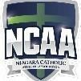

Please Print

Whereas (the Reason)

______________________________________________________________________________________________

______________________________________________________________________________________________

______________________________________________________________________________________________

_____________________________________________________________________________________________

Be it resolved that (the Motion)

______________________________________________________________________________________________

______________________________________________________________________________________________

______________________________________________________________________________________________

Please make reference to the NCAA Constitution Page, Article, and Section that this motion addresses.

Page number _____________________; Article number ______________________; Section ______________________

If a Motion addresses a policy found in a Sport Package - indicate page number and Article number.

Sport__________________________; Page number _______________________; Article_______________________.

Principal’s Signature ________________________________________ Date:__________________

Mover_______________________________________ School___________________________________

Seconder___________________________________ School___________________________________

Date ________________________________________

Appendix A – Notice of Motion

Appendix B - NCAA Co-participation - 2021-2022 - must have NCAA approval 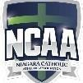

Student/athletes who wish to participate in a sport that is not offered at their home school may do so if they meet the criteria for Special Consideration NCAA Constitution and Policy Manual. For NCAA league play only.
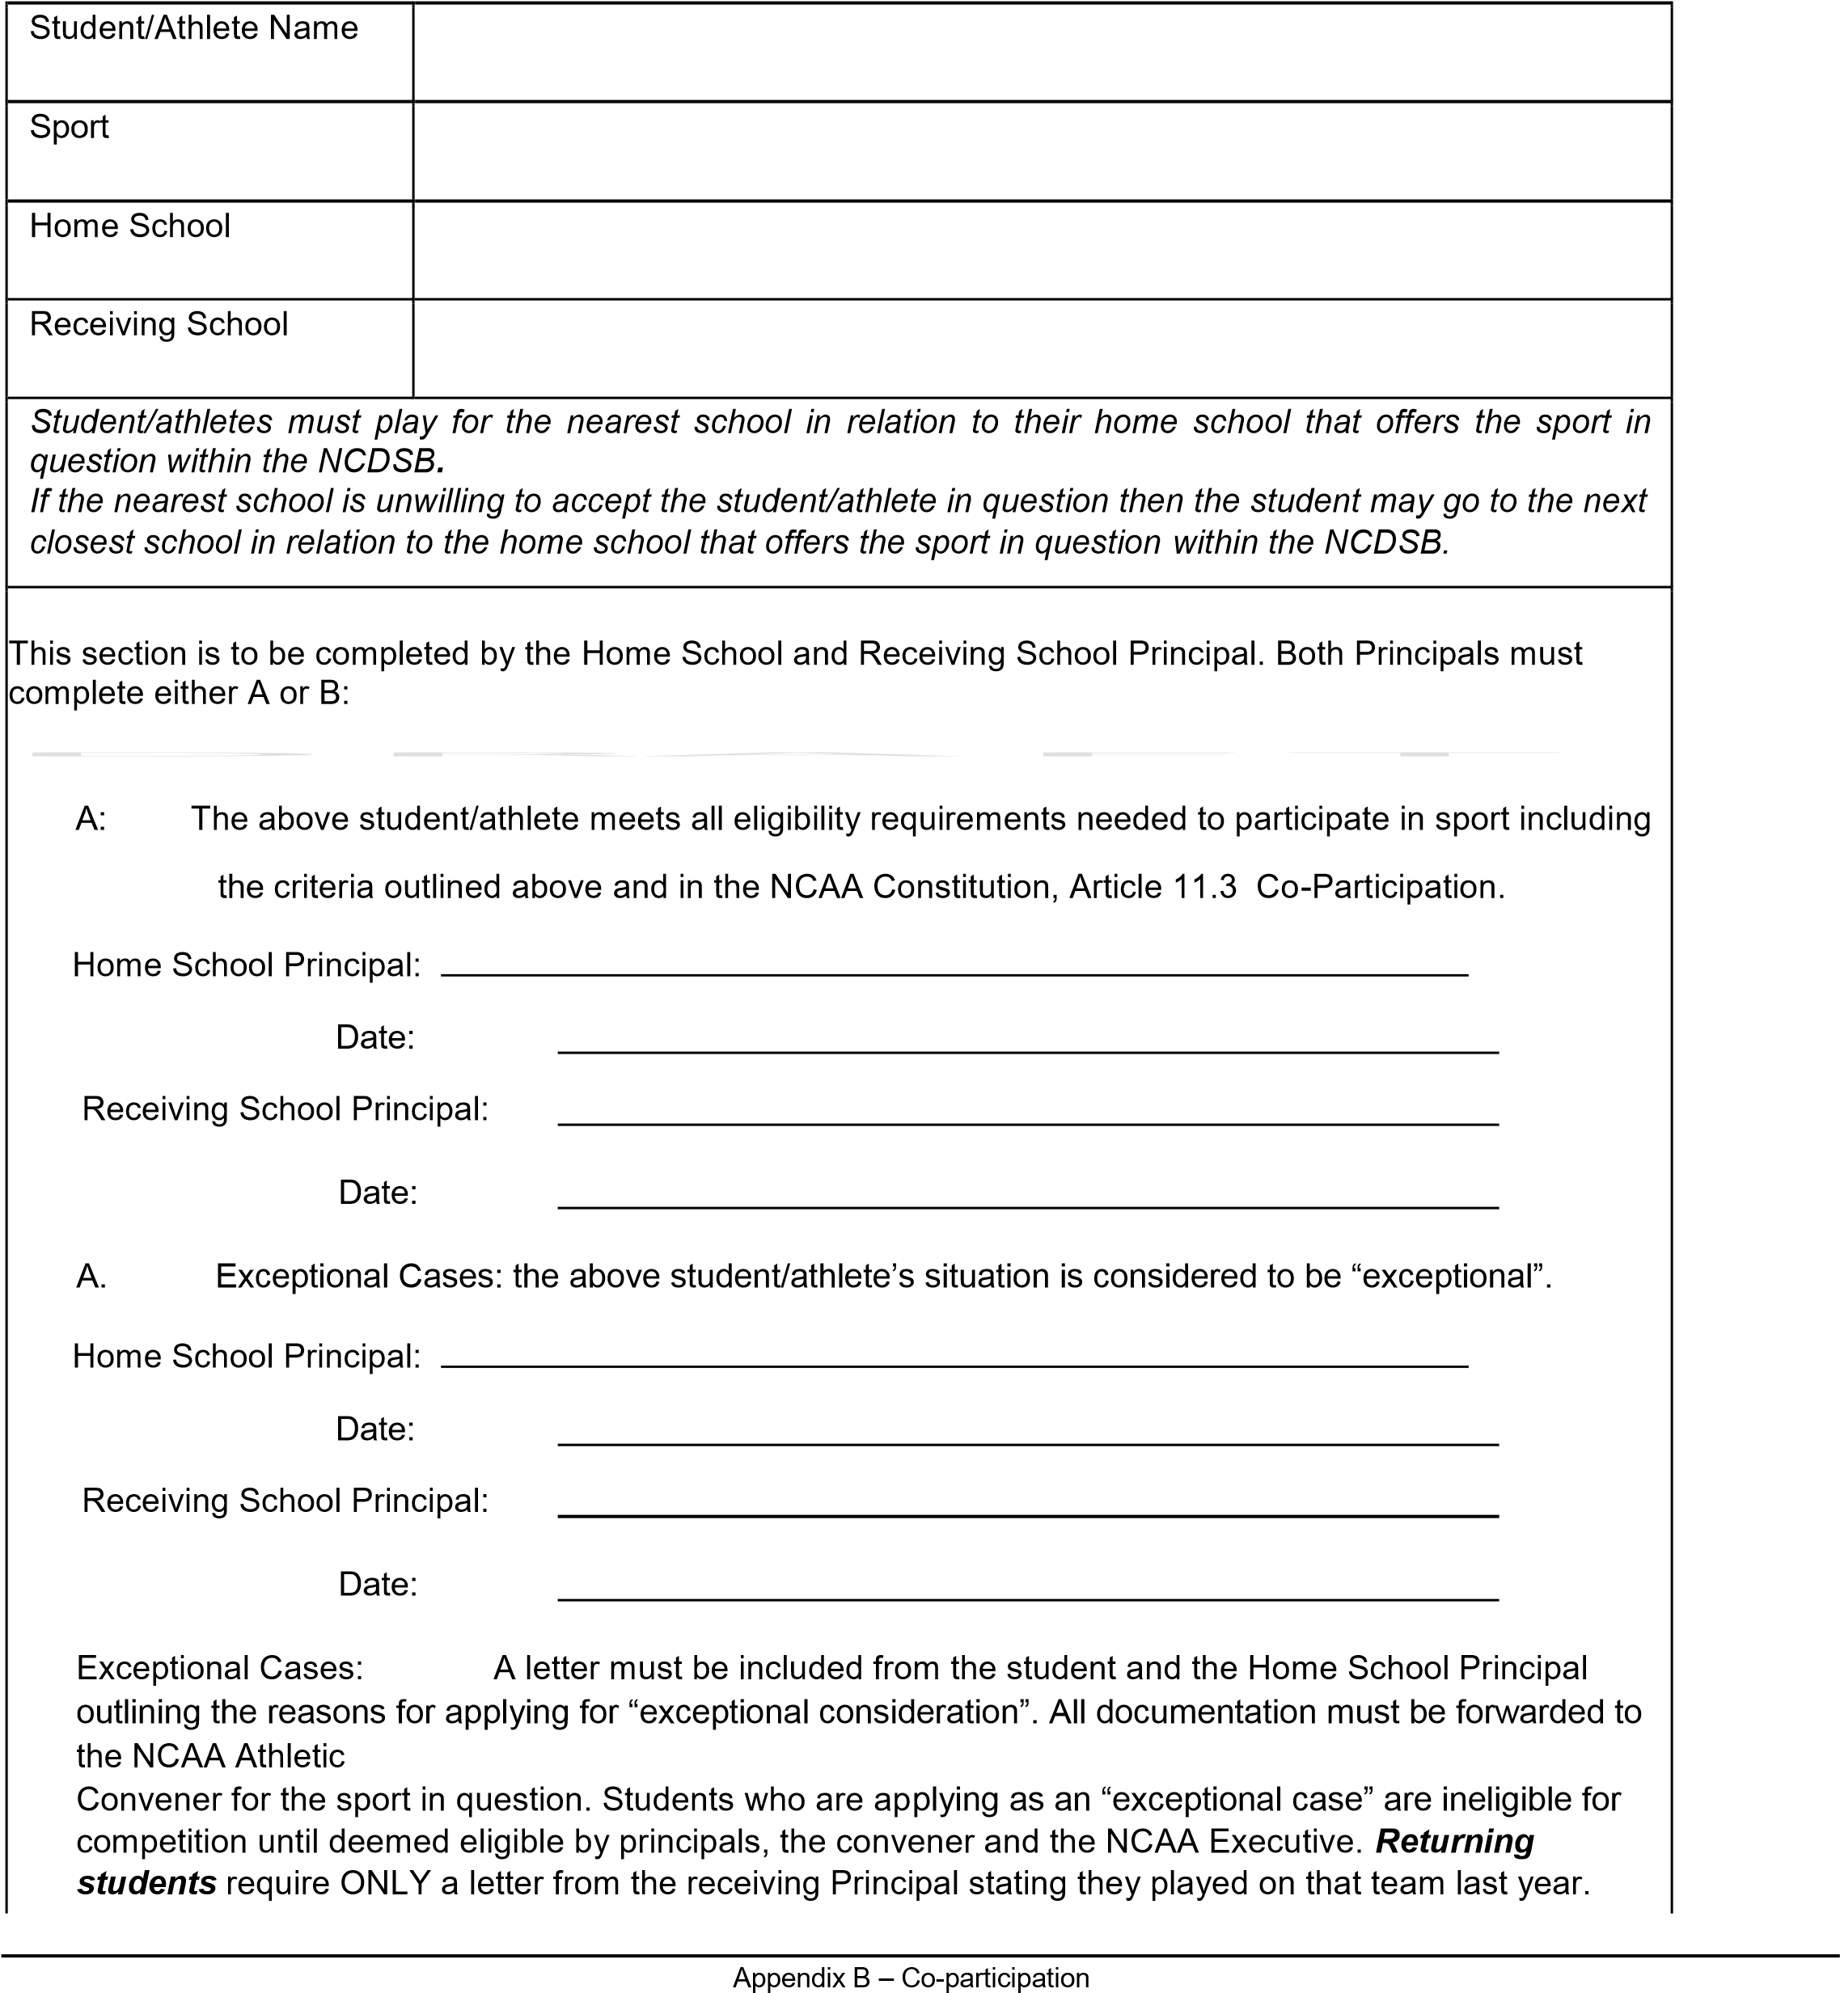

Appendix C - NCAA Intention sheet (one/sport; classification; gender)
2021-2022

This sheet must be completed and submitted to the Athletic Convenor at the individual sport body meeting.
Schools that do not submit a Declaration or an Intention Sheet for a sport will not be included in the schedule.

School: _____________________________

Sport: ______________________________ Male: Female:

Classification: Junior A _____ AA _____

Senior A ____ AA _____ AAA _____ AAAA _____

Declaring up: (Refer to NCAA Policies)

Has declared up to __________; from__________: A letter must be attached

School’s name:

Dates your school can not play:

Tournament dates must be included in these dates. No NCAA competition will be changed unless due to extenuating circumstances once the final schedule is issued – schools that are unable to honor the final schedule will forfeit the competition in question:

________________________________________________________________________________________________

________________________________________________________________________________________________

________________________________________________________________________________________________

________________________________________________________________________________________________

MIDGET  JUNIOR  SENIOR | COACH and/or SCHOOL contact (* If outside coach) | Home phone #  (This information must be provided) | Email  (This information must be provided)

_______________________________________ ____________________________________ Principal’s signature Date

Appendix C – NCAA Intention Sheet
Appendix D – NCAA School request for addition to league form 2021-2022

(Use this form if a school wants to declare up or move into a league after a schedule has been set- draft-to-final or final)

School: ________________________________________

Sport: _________________________________________

Male: ______________ Female: _____________

CLASSIFICATION:

JUNIOR A:________ AA: ________ SENIOR A: ________ AA: ________ AAA: ________ AAA:________

Declaring up:

______________________________________ (School Name) has declared up to

_______________________________; from:______________________________________

The request letter must be attached to this request if your school is declaring up its classification.

Dates that your school cannot play:

____________________________________________________________________________________

____________________________________________________________________________________

____________________________________________________________________________________

____________________________________________________________________________________

____________________________________________________________________________________

A fee of $100.00 (paid to the NCAA Convenor) must accompany this form before the leaque will be re-rescheduled.

____________________________________ ___________________________
Principal’s Signature Date

Appendix D- NCAA request for additional team

Appendix E – Proposal for the addition of NCAA sport form 2021-2022

Sport: _________________________________________

Gender: Male: ______________ Female: _____________ Co-ed:_______________

Rule book: __________________________________________________________________

Convenor/s: _________________________________________________________________

Play to Stop: NCAA: ____________ SOSSA: ____________ OFSAA: ___________

Schools supporting the addition of Sport:

Total initial equipment cost per team (Please attach a detailed list with prices)

Total yearly equipment renewal cost per team (Please attach a detailed list with prices)

Officials Cost Per Game: ____________ Per Season: _____________

Transportation Cost Per Game: ____________ Per Season: _____________

Facilities Required: ___________________________________________________________________

Share of the start up cost to be assumed by:
Board $____________ School $____________ Players $____________ Fundraising $____________

Share of the yearly cost to be assumed by:
Board $____________ School $____________ Players $____________ Fundraising $____________

Other Costs and issues which should be considered:

____________________________________ ___________________________
Principal’s Signature Date

Appendix E- Proposal for the addition of NCAA sport form 2021-2022
Appendix F – NCAA Transfer Committee

2021-2022

This form should be completed by student-athletes who are applying for transfer under sections B(i) and B (ii). An email is also acceptable.

Note: This form must be signed by both Program Chairs of Health and Physical Education/Co-curriculars from the sending and receiving schools.

Athlete’s name: _________________________________________

Date: __________________________

Receiving School: _________________________________________

Program Chair of H.P.E/Co-curriculars: _________________________________________

Program Chair of H.P.E/Co-curriculars Signature: _________________________________________

Sending School: _________________________________________

Please list below the sports played at the interschool level during the previous 12 months at the sending school stated above. Participation includes any type of interschool activity such as scrimmages between schools, exhibitions game, matches, etc…

Program Chair of H.P.E/Co-curriculars: _________________________________________

Program Chair of H.P.E/Co-curriculars Signature: _________________________________________

____________________________________ ___________________________
Principal’s Signature Date

Appendix F – NCAA Transfer Committee

Appendix G – Declaring 2021-2022

Fall Sports

School Name: __________________________________________

Memo to: NCAA Principals and Individual School Program Chair of Health and Physical Education/Co-curricular

Submitted by: NCAA Meeting in June According to the NCAA Constitution “Schools within the NCAA must declare their intention to run a Fall sport by June.” For organizational purposes would you complete the following chart indicating the Fall sports that your school will be participating in and email to the convenor.

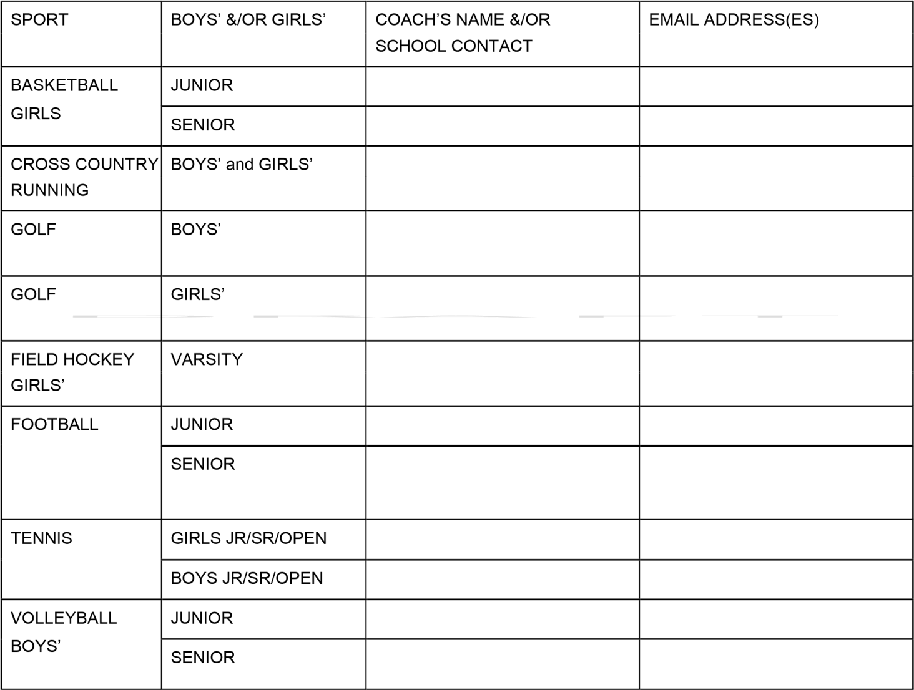

Appendix C must be completed for each sport that a school wants to participate in and brought to the first NCAA meeting before the beginning of Fall sports.

____________________________________ ___________________________
Principal’s Signature Date

Appendix G – Declaring 2021-2022 Fall Sports
Appendix H – Declaring 2021-2022

Winter Sports

School Name: __________________________________________

Memo to: NCAA Principals and Individual School Program Chair of Health and Physical Education/Co-curricular

Submitted by: NCAA Meeting in October
According to the NCAA Constitution “Schools within the NCAA must declare their intention to run a Winter sport by October.” For organizational purposes would you complete the following chart indicating the Winter sports that your school will be participating in and email to the convenor.

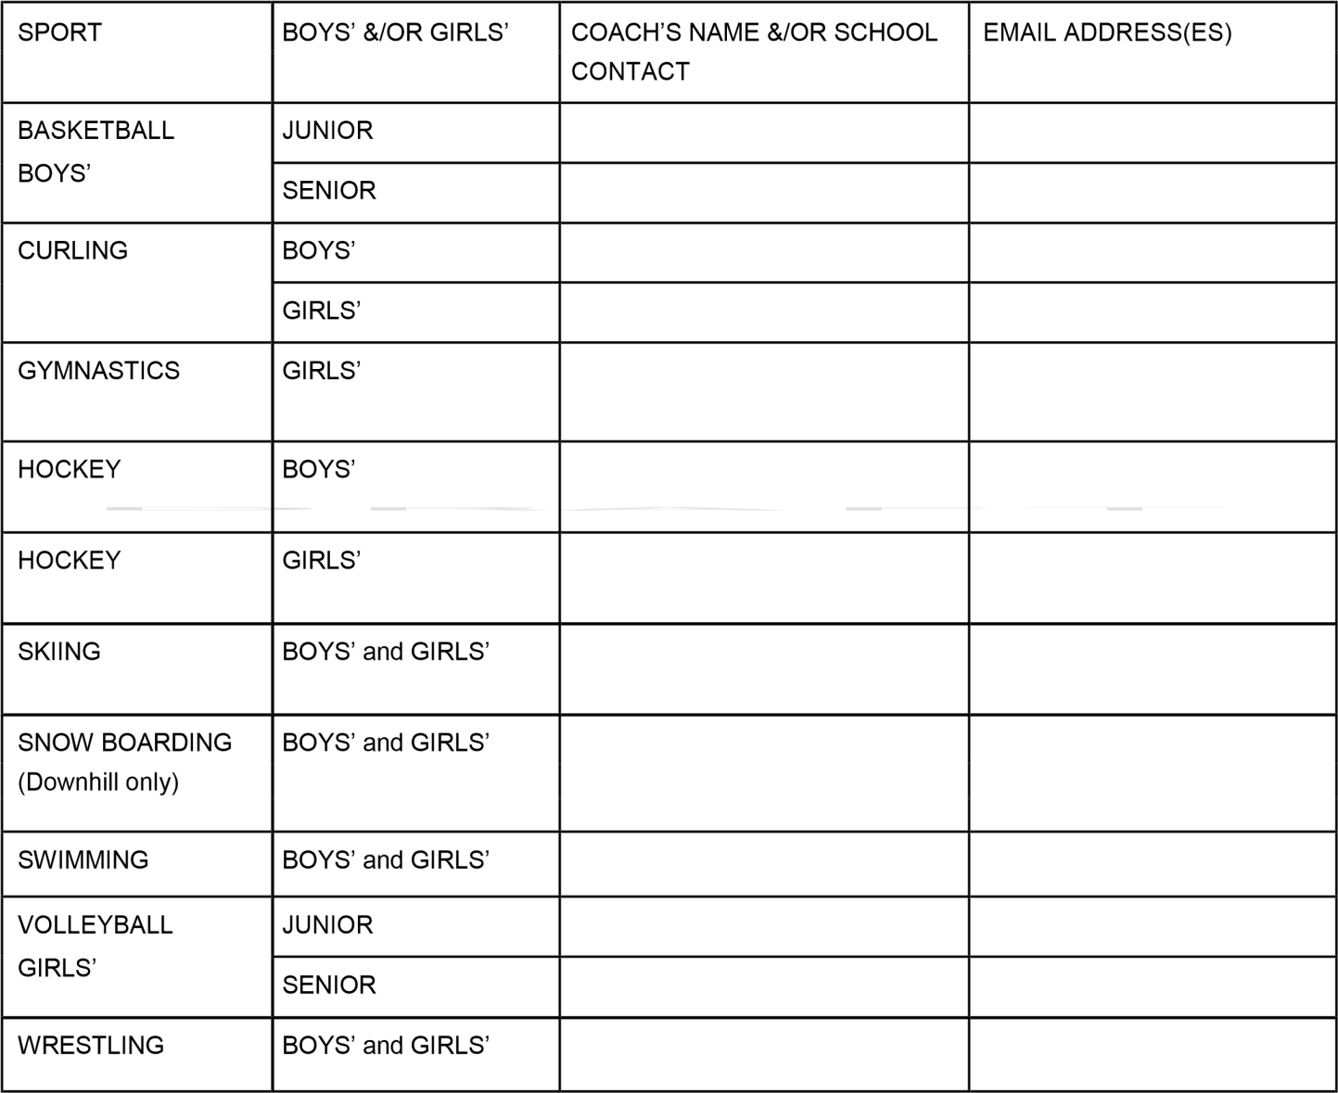

Appendix C must be completed for each sport that a school wants to participate in and brought to the first NCAA meeting before the beginning of Winter sports.
____________________________________ ___________________________
Principal’s Signature Date
Appendix H – Declaring 2021-2022 Winter Sports
Appendix I – Declaring 2021-2022

Spring Sports

School Name: __________________________________________

Memo to: NCAA Principals and Individual School Program Chair of Health and Physical Education/Co-curricular

Submitted by: NCAA Meeting in October
According to the NCAA Constitution “Schools within the NCAA must declare their intention to run a Spring sport by February.” For organizational purposes would you complete the following chart indicating the Spring sports that your school will be participating in and email to the convenor.
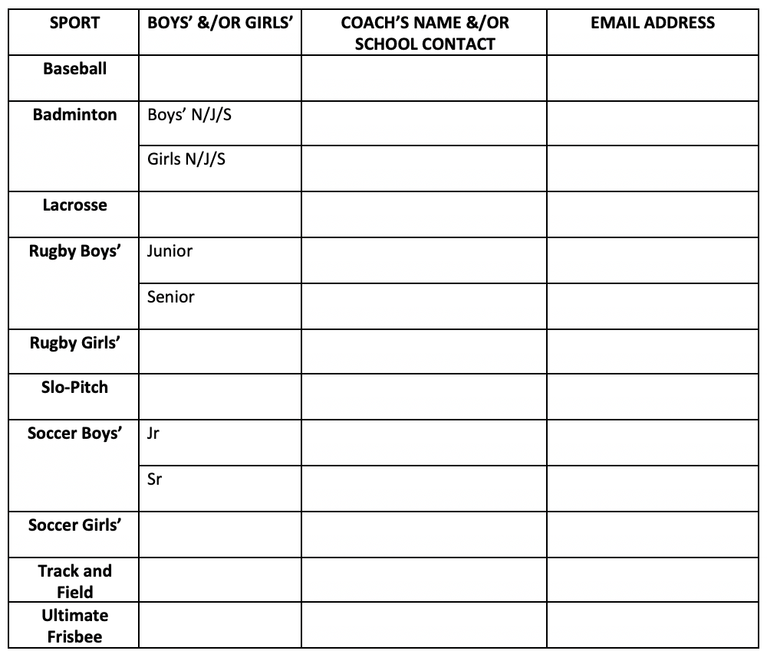

Appendix C must be completed for each sport that a school wants to participate in and brought to the first NCAA meeting before the beginning of Spring sports.

___________________________________ ___________________________
Principal’s Signature Date
Appendix I – Declaring 2021-2022 Spring Sports
Appendix J – Outside Permission Form for Secondary Coach 2021-2022

________________________________________________ Club Coach Permission Form (Identify sport)

I (Name of head coach), _____________________________________________, head coach of

(Name of sport) _________________________________________ of (school name)

________________________________ give (name of Club coach) ____________________________,

Club coach of (Student athlete’s name) ______________________________, permission during the

(name of sport) ____________________________________ season to assist or coach that student

athlete in anyway during the (Name of sport) ___________________________

season of (year) ______________.

Signature of the Student/Athlete: ___________________________________
Signature of High School Coach: ___________________________________
Signature of Club Coach: __________________________________________
Signature of Principal :_____________________________________________

Date: _______________________________

Appendix J – Outside Permission Form for Secondary Coach 2021-2022
To be accompanied by vulnerable sector check

Appendix K – Co-curricular Request to Resume Participation

This form can be completed by the student’s physician or parents/guardian or both.

Physician Consent

_____________________________, have tested/examined __________________________________
(Name of doctor) (Name of Student)
After an injury/illness to or affecting his/her ________________________________________________
(Body part)
And certify that, in my professional opinion, he/she will be ready to resume participation in,

_________________________________________________ as of _____________________________
(Name of sport) (Date)

Comments:

--------------------------------------------------------------------------------------------------------------------------------------------

Parent and Guardian Consent

_____________________________, acknowledge that __________________________________
(Name of parent/guardian) (Name of Student)
Has received doctor’s care for an injury/illness affecting _______________________________________
(Body part)
And request their participation to resume to ______________________________________
(Sport/Activity)
as of _____________________________ ________________________________
(Date) (Parent/Guardian Signature)

Comments:

This completed form is to be returned to the teach/coach/school by any athlete who has missed a practice or game due to an injury or illness requiring medical attention. NOTE: if the injury sustained was a concussion please complete the Concussion Protocol. This can be obtained from the teacher/coach/school and at www.niagaracatholic.ca

Appendix K – Co-curricular Request to Resume Participation

Appendix L: Request for Exception to Participate in a NCAA game/event under Article 10 II. Suspensions
To be used only when athlete/coach is ejected in their last NCAA game/event prior to participating in next applicable sport season

School Name: ________________________
Exception Request for (Please Check):
Student Name: ____________________________ Coach Name: ____________________________

Sport/event: Division: _____________________________ Date________________________

Ejection Criteria: ____________________________________________________________

Reason for Exception Request: _____________________________________________________________
_____________________________________________________________________________
_____________________________________________________________________________
_____________________________________________________________________________

Head Coach Name: ________________________ Signature: ____________________________

Program Chair of Health and Physical Education/Co-curriculars Signature: _____________________________________

Principal Signature: ______________________________________________________________

Date Submitted: __________________

Time Submitted: __________________

Official Result: Exception Request Approved: Exception Request Denied:
Explanation/Decision of Sanctions and Protest Committee: _______________________________________
_______________________________________________________________________________
_______________________________________________________________________________

Chair- Sanctions and Protest Committee Signature: _________________________________________________________

Appendix L – Request for Exception

