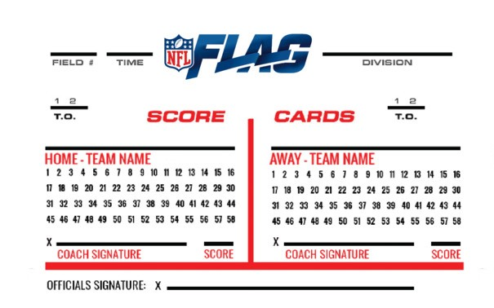

Roster:

1.________________ 7. __________________

2. _________________ 8. __________________

3. _________________ 9. __________________

4. _________________ 10. _________________

5. __________________ 11. _________________

6. __________________ 12. __________________

Roster:

1.________________ 7. __________________

2. _________________ 8. __________________

3. _________________ 9. __________________

4. _________________ 10. _________________

5. __________________ 11. _________________

6. __________________ 12. __________________

Roster:

1.________________ 7. __________________

2. _________________ 8. __________________

3. _________________ 9. __________________

4. _________________ 10. _________________

5. __________________ 11. _________________

6. __________________ 12. __________________